PRESSEHEFT
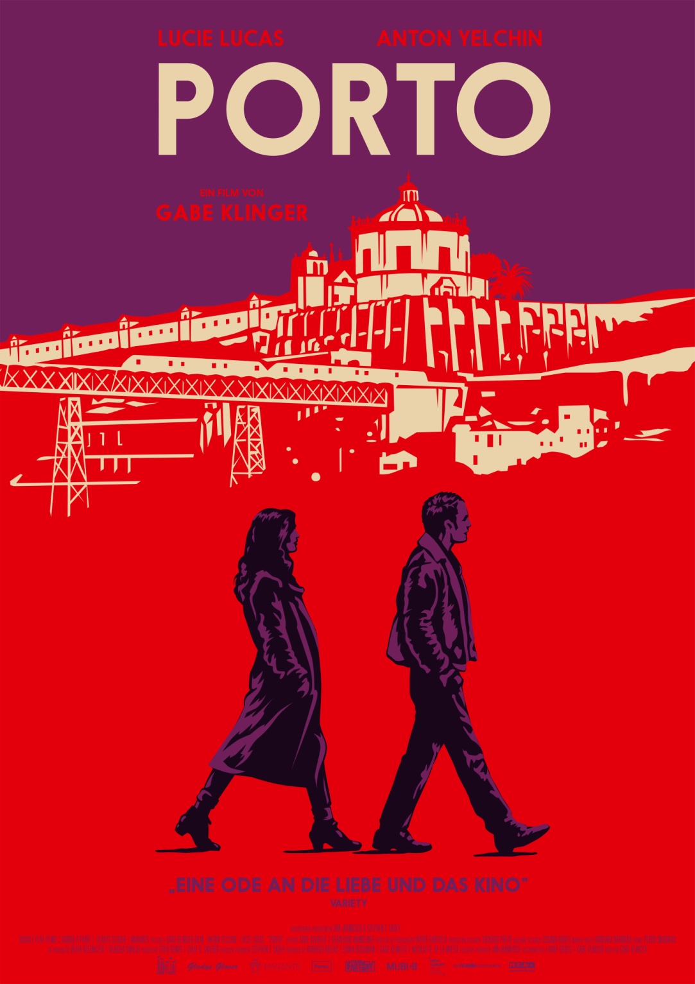
Ab 14.09.2017 im Kino!
Ausführender Produzent: Jim Jarmusch
Verleih: Presseagentur:
MFA+ FilmDistribution filmpresse meuser
Tel. 0941-5862462 Tel. 069-40 58 04-0
Fax: 0941-5861792 Fax: 069-40 58 04-13
info@mfa-film.de info@filmpresse-meuser.de
Pressematerial unter: http://www.mfa-film.de/kino/id/porto/
ÜBER DEN FILM
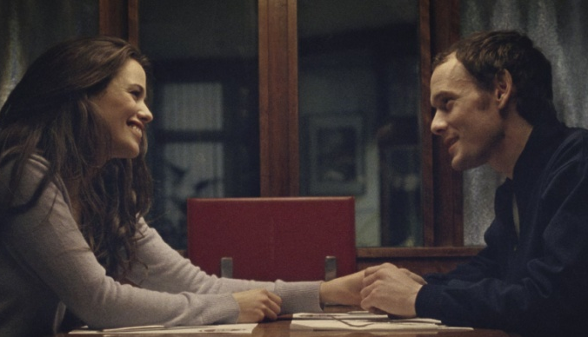
Porto, die alte portugiesische Hafenstadt mit ihrer mysteriösen, fast morbiden Atmosphäre ist der Ort, an dem Jake (Anton Yelchin) und Mati (Lucie Lucas) aufeinandertreffen. Beide sind fremd in der Stadt, beide sind Außenseiter, und beide sind auf der Suche. Als sie sich begegnen, ist es Anziehung, ja, Liebe auf den ersten Blick. Fremd, doch zugleich vertraut, stürzen sie sich Hals über Kopf in eine Affäre. Es ist nur eine einzige Nacht, die sie miteinander verbringen. Aber die Zeit scheint still zu stehen. Mit Blicken, Gesten und Worten schaffen sie eine geheimnisvolle und doch unauflösbare Verbindung. Die Vergangenheit lässt sich nicht zurückholen, aber die glücklichen und leidvollen Erinnerungen hinterlassen bei beiden ihre Spuren. Für immer.
PORTO ist der erste Spielfilm des amerikanisch-brasilianischen Regisseurs Gabe Klinger, gleichzeitig einer der letzten von Anton Yelchin (STAR TREK, ONLY LOVERS LEFT ALIVE), der im Juni 2016 auf tragische Weise ums Leben kam. Entstanden ist der Film unter der Mitwirkung von Jim Jarmusch (DEAD MAN, BROKEN FLOWERS) als Ausführender Produzent. Seine Weltpremiere feierte PORTO auf dem Internationalen Filmfestival San Sebastian, weitere Festivaleinladungen u. a. zum 60. BFI London Film Festival, dem Zürich Filmfestival und den 50. Internationalen Hofer Filmtagen folgten.
Bereits 2013 gewann Gabe Klinger bei den 70. Internationalen Filmfestspielen von Venedig den VENEZIA CLASSICI AWARD für den besten Dokumentarfilm (DOUBLE PLAY: JAMES BENNING AND RICHARD LINKLATER).
"The presence of the late Anton Yelchin amplifies the bittersweet melancholy of Gabe Klinger's graceful romantic miniature ... A film that's in love with love, in love with cinema, and concerned that neither is built to last." (Variety)

TECHNISCHE DATEN
Regie: Gabe Klinger
Darsteller: Anton Yelchin, Lucie Lucas, Françoise Lebrun, Paulo Calatré
Originaltitel: PORTO
Land: Portugal, USA, Frankreich, Polen
Jahr: 2016
Genre: Romantik, Drama
Laufzeit: 75 Min.
Sprachfassung: DtF / OmU
Format: DCP, Blu-ray
Kinostart: 14.09.2017
FSK: ab 12 beantragt
Pressebetreuung: Filmpresse Meuser
ANTON YELCHIN (JAKE)

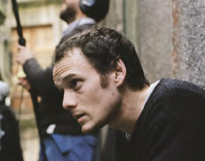
Anton Yelchin begann seine Schauspiel-Karriere im Alter von 9 Jahren und hat in über 30 Filmen mitgespielt. Sein Durchbruch gelang ihm durch eine Rolle in der Serie EMERGENCY ROOM und dem Film HEARTS IN ATLANTIS, für den er den Young Artist Award gewann. Zu seiner Filmografie zählt Jim Jarmuschs ONLY LOVERS LEFT ALIVE; J.J. Abrams STAR TREK: INTO DARKNESS und Nick Cassavetes ALPHA DOG. In LIKE CRAZY, der auf dem Sundance Festival den Grand Jury Preis gewann, spielte Anton Yelchin an der Seite von Jennifer Lawrence und Felicity Jones und neben Nicolas Cage spielte er in THE DYING OF THE LIGHT von Paul Schrader, so wie in WEG MIT DER EX von Joe Dante und in Jeremy Sauliers GREEN ROOM. Yelchin starb am 19. Juni 2016 im Alter von 27 Jahren an den Folgen eines schweren Autounfalls.

LUCIE LUCAS (MATI)
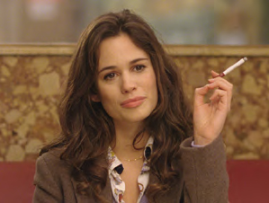
Lucie Lucas ist seit Ihrer Kindheit Schauspielerin und hat schon bei mehreren Theaterstücken, Fernsehserien und Filmen mitgespielt. Dazu zählen der Spielfilm 15 ANS ET DEMI mit Daniel Auteuil und LE MISSIONAIRE. Seit 2010 spielt sie den Hauptcharakter in der beliebten Fernsehserie CLEM von TF1. Lucas hatte einige nennenswerte Rollen, z.B. in THE LITTLE MURDERS OF AGATHA CHRISTIE, LE PIGEON oder der französischen Comedy-Serie NON CHERS VOISINS, die immer noch läuft. PORTO ist ihr erster englisch-sprachiger Film und ihre erste große Rolle in einem Spielfilm.

GABE KLINGER (REGISSEUR)

Gabe Klinger ist ein preisgekrönter Filmemacher, Professor und Autor. Seine umjubelte Dokumentation DOUBLE PLAY gewann 2013 auf dem Filmfest Venedig einen Löwen in der Kategorie „Beste Dokumentation“ und wurde auf über 100 Events und Tagungen aufgeführt, darunter das SXSW, dem Rotterdam Filmfestival, dem Internationalen Dokumentationen Filmfest Kopenhagen (CPH:DOX), dem Toronto International Filmfestival und dem IFC Center. Klingers Artikel aus seiner Zeit als Filmkritiker wurden in der Sight & Sound, dem Film Comment und Cinema Scope veröffentlicht. Klinger hat an der Universität Illinois und dem Columbia College den Studiengang Film unterrichtet.

JIM JARMUSCH (EXECUTIVE PRODUCER)

Jim Jarmusch ist Regisseur, Musiker, Filmproduzent und eine der größten Ikonen des Welt- und Independent-Kinos. Seinen Durchbruch hatte er 1984 mit dem Spielfilm STRANGER THAN PARADISE, der auf dem Cannes Filmfestival mit der Camera d´Or ausgezeichnet und zu einem seiner berühmtesten amerikanischen Filme wurde. Zu seinen Werken zählen außerdem Klassiker wie DOWN BY LAW, DEAD MAN, GHOST DOG und BROKEN FLOWERS. Seine letzen beiden Filme ONLY LOVERS LEFT ALIVE und PATERSON wurden auf den Filmfestivals in Cannes, Toronto und New York gezeigt und überall auf der Welt vertrieben.

INTERVIEW MIT GABE KLINGER
You were born in Brazil but live in the U.S. What are you doing shooting a film in Europe? And what drew you to the intimate Portuguese city of Porto?
Well, you know, in Europe you have producers who genuinely love art cinema and arthouse culture and a public subsidies system that supports this type of production. I had a really good experience making Double Play (2013), my previous film, with support from French and Portuguese
people. I ended up going back to those same people to make Porto. My first choice for the film was actually Athens. But then Greece had a liquidity crisis in 2014 and while we were waiting for things to stabilize my friend and producing partner Rodrigo Areias, who lives in northern Portugal in a small town called Guimarães, suggested Porto. After scouting locations there with Wyatt Garfield, the film’s cinematographer, I became convinced that it was exactly what we were looking for. And then the city of Porto and the Porto Film Commission were incredibly supportive in a way that made it clear it would be the right choice logistically. As you say, it’s an intimate place. It has a big city feel
without being overwhelming. And aside from Manoel de Oliveira, there weren’t many filmmakers who shot in Porto. That novelty was appealing to us. I feel like I have to talk about Oliveira briefly here. He was a key influence, and not just because of the scarcity of films set in Porto. My first connection with the city was through his films. Douro, Faina Fluvial (1931), O Pintor e a Cidade (1956), and Porto of My Childhood (2001) are like great virtual maps Porto and so incredibly beautiful... of course they ended up influencing the visual design of our film.

Speaking of the film’s look, you have conceptualized a rather radical and adventurous way of visualizing time through cinematic material itself, using 35 mm, 16 mm and Super 8 film to evoke different aspects of Jake and Mati’s lives together and apart. How did this elaborate and beautiful solution come to you? Why was it important to use celluloid to express something important about people?

I wanted a visual canvas that would expand as the temporal space of the film narrowed. Super 8 would cover the most time – not screen time, but story time – and 35 mm would cover the least amount of story time but the most screen time and therefore serve as a microscope. It’s difficult to sustain an immersive sense of time in Super 8 because it only gives you impressions. The frame
is small, there’s not much depth, and you can only shoot for three minutes. With 35 mm you have a huge frame, a lot of detail, and can shoot for typically around ten minutes. Because there aren’t as many limitations, 35 mm allows you to conceptualize time in a more objective way. Jake and Mati are characters stuck in time. They are stuck in one night, even though they are no longer living
that one night. They are perhaps thinking about it or dreaming it. There’s something James Benning says that really resonates with me: “All of time is just memory.” That’s really what the film is about, and contrasting these different formats, exploring what they could reveal to the audience about how we live time through memory (and dream), I could begin to say something really poignant about these two characters.

Tell me more about Jake and Mati. They are an American and a French woman who cross paths in Portugal. Neither was looking for the other, yet they found each other and a romance in a place that isn’t their true homes, Jake exiled from his parents and Mati abroad with her Portuguese
lover. What is the nature of their attraction?

Attraction is a mystery to me. I always balk when people look at couples and say things like, “oh, they’re perfect for each other,” or (pejoratively or complimentarily) “they deserve each other.” How do you know? You may be perfect for someone, but your life isn’t perfect. Or you may
be perfect for your partner but for whatever reason you don’t want to be with your perfect person. One thing I will say is that loneliness is a great unifier, as paradoxical as that is. When you’re an outsider in any environment, your feelings of loneliness are exacerbated and you seek connection, and sometimes those connections are strange, mysterious... I didn’t want to give Jake and Mati too much psychology. It’s funny, I believe in psychology in my own life but I don’t really believe in it in cinema. Larry Gross, my co-writer, was pro backstory and I was sort of con and we found a middle ground. A lot of backstory didn’t end up in the film.
In the absence of backstory, we learn much about these characters from their behavior, how they act – towards each other, certainly, but also in Anton Yelchin and Lucie Lucas’s different acting styles. Anton is curled inward: intense, earnest, almost contorted by holding in his passion. He is utterly honest. Lucie is more fresh and open, and yet that seems perhaps a mask, for she hints at her character’s psychological trouble and habitual lying. How did you work with each actor to develop their characters that live so much in the moment for us?
Casting is 90%, maybe more. In both Anton and Lucie’s cases, I listened to how they interpreted their
characters, and sometimes those interpretations matched up with my own and sometimes they didn’t, and in the latter cases, I was intrigued enough to want to explore further with them. The bottom line is that you don’t want something that only comes from you, the director, because
that doesn’t have much dimension. Anton and Lucie showed me that they were going to be active in fleshing out their characters from day one. They brought in a lot of stuff from their own lives, stuff I can’t really speak to, but that I could definitely relate to in one way or another. The other 10% that’s not casting is the actual work you do as a director. Sometimes actors can go a bit too far or not far enough and you want to help them achieve the right volume in their performance. Then there’s the practical stuff: if an actor asks you for a few more takes to try something different, you have to get the crew excited to keep going and make sure the first A.D. isn’t breathing down anyone’s neck.
Tangentially but related: Anton and Lucie really appreciated that I stuck mostly to master shots. I found out that actors are really annoyed by coverage. They prefer a long take to figure shit out. It makes sense.
Your first feature film was Double Play, a documentary about the two great American filmmakers Richard Linklater and James Benning. What was it like making the leap into fiction? What challenges and freedoms did you find in this shift in storytelling?

Creating a world from scratch – man, I had no idea what I was getting into. I had never worked with an art department before, with a wardrobe department, with hair and makeup… It’s a lot of coordination and in depth thought to visualize your world, you’re in production meetings for weeks before you start... In that sense it’s nothing like certain types of documentary.
But then there are similarities, things you find out about your directorial style in relation to performance, for example. There’s such a thing as documentary performance, which I don’t think I realized when I made Double Play. Two years later, directing Anton and Lucie in Porto, it dawned on me that I actually have a preference, a style, which is to give my performers as much freedom as possible. Define a few frameworks and limitations and then let them do their thing.
I think at the end of the day I prefer shooting fiction. Documentary subjects can disappear or bow out, you don’t have a contract with them, you’re not paying them, they can change their minds, etc. It’s too stressful for me. On a fiction set, you have more control, more hours, more people to delegate to... Editing is essentially the same process, however: you just have a responsibility to form
a relationship with the images that you were able to get during the shoot. With Double Play, which I edited on my own, that relationship came very naturally, I understood the potential of my images... On the contrary, at a certain point in the post-production with Porto I ended up needing to fire myself as editor and hired someone else in order to have a bit of distance. Realizing that and taking a step back was the most challenging aspect of making the film.

As a film critic and programmer yourself, did you look for inspiration in other films, especially to guide this new fictional endeavour? The profound importance of time, its personal perception and interpersonal impact, brought to mind films by Alain Resnais.

This is the part where you don’t want to give away too much, right? It’s more fun to see what connections other people draw with the film as the main clue. Since you mention Resnais, I will say that I definitely went down a Muriel (1963) rabbit hole during both the writing and editing stages. But that movie is way more sophisticated than what I’m up to. It’s still so radical. If I wanted to make a film like Muriel, financiers nowadays would run away screaming. Other influences, direct and indirect: Fleischer cartoons (especially Betty Boop), Rivette (L’amour fou, Out 1...), Louis C.K. (Louie...), Godard (Bande à part...), McCarey (An Affair to Remember, The Awful Truth…), Dover
Koshavili’s Late Marriage, Sam Fuller’s The Steel Helmet, Petzold’s Phoenix, Alan Clarke’s Elephant, Lisandro Alonso (Los Muertos…), Jim Abrahams and the Zucker bros.’ Airplane!, George and Mike Kuchar’s 8 mm films... Hopefully that’s a diverse enough list that no one can point at my
film and say, “He’s copying this particular filmmaker or this particular style.” The reality is, I’m copying everybody.

We can certainly see some of your touch points behind and in front of the camera: Jim Jarmusch is an executive producer and Françoise Lebrun, whom we love for The Mother and the Whore (1973), has a moving appearance as Mati’s disconsolate mother. I imagine it is inspiring to collaborate with figures so important to cinema’s living history.

For me – and it was the same on Double Play, where I got to work with people like André Labarthe – the most stimulating part of my work is engaging in the history of cinema. Françoise’s performance in the Eustache is one of the all-time greats, I think. It’s up there with Falconetti in The Passion of Joan of Arc (1928). And I grew up watching Jarmusch’s films on VHS tapes given to me by grandmother. In the early ‘90s when I first discovered him, Jarmusch was established but still not a household name. His influence is widespread now. I watched Stranger Than Paradise again recently and it’s still so radically modern. It’s in the DNA for so many things that came after.
I’ve known Jim and his life partner Sara Driver for a while now. We keep in touch and when I’m in New York I try to see them. Jim was so warm and receptive to me when I pitched the idea for Porto. I was so nervous. He thought about the treatment for day or so, and then he called me to say he’d come on board. I was in a supermarket when I got the call and I think I did a little victory lap in the produce section with my shopping cart.
Jim’s role in the film was spirit guide. You can’t really have that as a film title, unfortunately, but it’s more accurate than executive producer. What he did was guide me through different parts of the process, give creative feedback, offer moral support, and introduce me to a few people on the business side. If you have the possibility to invite artists who you love into your filmmaking world, then why not? This is what Jarmusch does frequently in his films. I’m thinking of Robert Mitchum in Dead Man (1995) or Screamin’ Jay Hawkins in Mystery Train (1989)... You end up learning a lot from these people. You have to assume the posture of student as a filmmaker. There’s a 125-year history that comes before you and you can never forget that.

STAB
CAST

Anton Yelchin, Lucie Lucas, Françoise Lebrun, Paulo Calatré

CREW

Regisseur Gabe Klinger
Drehbuch Larry Gross, Gabe Klinger
Kamera Wyatt Garfield
Schnitt Gabe Klinger, Géraldine Mangenot
Produktionsdesign Ricardo Preto
Produktionsfirmen Bando à Parte, Gladys Glover, Double Play Films, Madants
Produzenten Rodrigo Areias, Sonia Buchman, Gabe Klinger, Nicolas R. de la Mothe,
Todd Remis, Julie R. Snyder
Co-Produzenten Klaudia Śmieja, Beata Rzeźniczek
Executive Producers Jim Jarmusch, Stephen T. Skoly

