INTERVIEW WITH
Presseheft

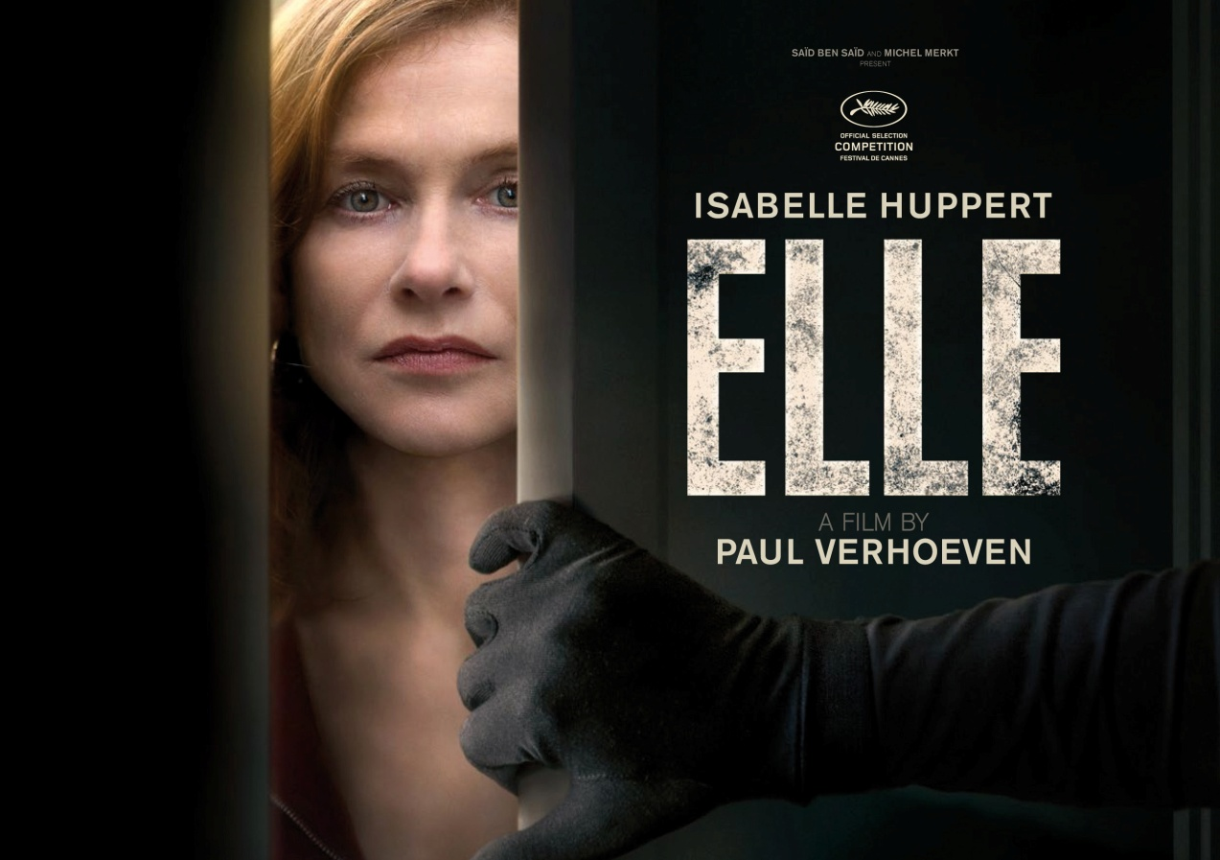
Kinostart: 16.02.2017

Regie Paul Verhoeven
Darsteller Isabelle Huppert, Laurent Lafitte,
Anne Consigny, Christian Berkel, Charles Berling u.a.

Verleih: Presseagentur:
MFA+ FilmDistribution filmpresse meuser
Tel. 0941-5862462 Tel. 069-40 58 04-0
Fax: 0941-5861792 Fax: 069-40 58 04-13
info@mfa-film.de info@filmpresse-meuser.de

Pressematerial unter:
http://www.mfa-film.de/kino/id/elle/

Synopsis

Michèle (Isabelle Huppert), Chefin einer erfolgreichen Firma für Videospiele, wirkt wie eine Frau, der nichts etwas anhaben kann. Unnahbar führt sie mit der gleichen Präzision und Kalkül ihre Firma wie ihr Liebesleben. Als Michèle eines Tages in ihrem Haus von einem Unbekannten angegriffen und vergewaltigt wird, scheint sie das Vorgefallene zunächst kalt zu lassen. Doch ihr Leben ist über Nacht ein anderes geworden. Resolut spürt sie den Angreifer auf und verstrickt sich mit ihm in ein gefährliches Spiel aus Neugier, Anziehung und Rache. Es ist ein Spiel, das jederzeit außer Kontrolle geraten kann …

Mit Ende Siebzig ist Paul Verhoeven (BASIC INSTINCT, ROBOCOP) nach mehr als 15 Jahren zum Genrefilm zurückgekehrt - und hat für ELLE die vielleicht besten Kritiken seiner langen Karriere bekommen. Ausgerechnet für einen Rape-Revenge-Thriller, der provokant mit Opfer- und Täterrollen spielt, trotz des Themas erstaunlich humorvoll ist und auf jegliche Moralisierung verzichtet. Das verdankt Verhoeven nicht zuletzt Isabelle Huppert, die einer fast unmöglichen Rolle absolute Glaubwürdigkeit verleiht.

ELLE feierte seine umjubelte Weltpremiere auf den Internationalen Filmfestspielen von Cannes 2016.
Basiert auf Philippe Djians („Betty Blue“) Roman „Oh…“.
Für die Kategorie „Bester fremdsprachiger Film“ wurde ELLE von Frankreich als Oscar-Beitrag 2017 ausgewählt.
Zudem gibt es Gerüchte über Isabelle Hupperts Aussichten, bei den Academy Awards 2017 den Preis „Beste Hauptdarstellerin“ zu gewinnen. Als sie gefragt wurde, ob sie den Oscar gerne gewinnen würde, lautete ihre Antwort: „Nennen Sie mir eine Schauspielerin, die das nicht möchte.“
ELLE von Paul Verhoeven ist neben jeweils zwei weiteren Filmen in den Hauptkategorien "Bester Film", "Beste Regie" sowie "Beste Darstellerin" (Isabelle Huppert) für den 29. Europäischen Filmpreis nominiert.

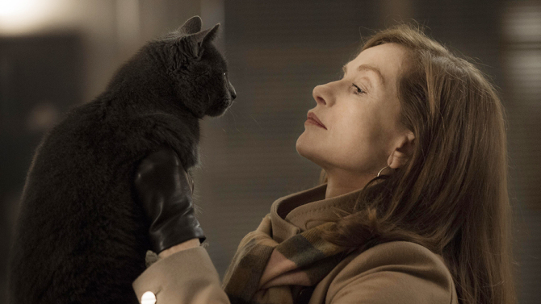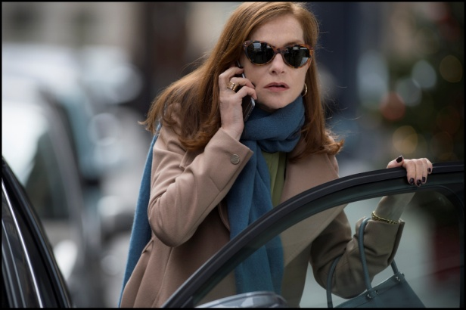

Cast & Crew

Michèle Isabelle Huppert
Patrick Laurent Lafitte
von der Comédie-Française
Anna Anne Consigny
Richard Charles Berling
Rebecca Virginie Efira
Robert Christian Berkel
Irène Judith Magre
Vincent Jonas Bloquet
Josie Alice Isaaz
Hélène Vimala Pons
Ralf Raphaël Lenglet
Kevin Arthur Mazet
Kurt Lucas Prisor
Phillip Kwan Hugo Conzelmann
Omar Stéphane Bak
___________________________________________________________________________________
Regie Paul Verhoeven
Drehbuch David Birke
Produzent Saïd Ben Saïd, Michel Merkt
Koproduzent Thanassis Karathanos, Kate Merkt, Diana Elbaum,
Sébastien Delloye, François Touwaide
Herstellungsleiter Oury Milshtein
Kamera Stéphane Fontaine - AFC
Schnitt Job ter Burg - NCE
Regieassistent Brieuc Vanderswalm
Kostüme Nathalie Raoul
Ausstattung Laurent Ott
Script Supervisor Bénédicte Darblay
Casting Constance Demontoy
Musik Anne Dudley
Ton Jean-Paul Mugel, Alexis Place, Katia Boutin
Mischung Cyril Holtz
Maske Sophie Farsat, Thi Loan Nguyen
Hairstylist Frédéric Souquet

Based on the novel “Oh…” by PHILIPPE DJIAN © Philippe Djian et Éditions Gallimard
a French-German coproduction SBS PRODUCTIONS TWENTY TWENTY VISION FILMPRODUKTION FRANCE 2 CINÉMA
in coproduction with ENTRE CHIEN ET LOUP and PROXIMUS with the participation of CANAL + FRANCE TÉLÉVISIONS OCS du CENTRE NATIONAL DU CINÉMA
ET DE L’IMAGE ANIMÉE and of GERMAN FÉDÉRAL FILM BOARD - FFA with the support of TAX SHELTER DU GOUVERNEMENT FÉDÉRAL BELGE
CASA KAFKA PICTURES BELFIUS and the support of CINÉMAGE 7 DÉVELOPPEMENT
© 2015 SBS PRODUCTIONS - SBS FILMS - TWENTY TWENTY VISION FILMPRODUKTION - FRANCE 2 CINÉMA - ENTRE CHIEN ET LOUP - PHOTOS : © 2015 GUY FERRANDIS / SBS PRODUCTIONS - CREDITS NOT CONTRACTUAL

Technische Facts
Frankreich, Deutschland, Belgien 2016
Laufzeit: ca. 130 Minuten
Sprachfassung: OmU und deutsche Fassung
FSK: ab 16 Jahren beantragt
Pressezitate

„Paul Verhoevens ELLE ist ein brillant-abgründiges, progressives, sauvergnügliches Spiel mit den Regeln des Thriller-Genres, der Rolle der Frau und dem guten Geschmack – anspruchsvoll, nie vorhersehbar und bis zur Schmerzgrenze politisch unkorrekt.“ Filmstarts.de

„Das Beeindruckende und Überraschende an diesem Film ist die Art, mit der Verhoeven seinen Stil und seine Weltsicht an einen typischen französischen Film anpasst: Es gibt verschiedene Liebhaber, Familienkrisen, furchtbare Eltern – in diesem Fall ein Vater, der einen Massenmord beging, als Michèle ein Mädchen war – und ein gewisses je ne sais quoi, das einen alles, selbst eine brutale, einschneidenden Attacke mit Vorsicht genießen lässt.“ Hollywood Reporter

„Ein hochriskanter Stoff liefert unerwarteten Lohn in diesem bemerkenswerten Rape-Revenge-Drama, einem möglichen Karriere-Highlight für Paul Verhoeven.“ Variety

„Die Spannung in ELLE kommt weniger von Verhoeven selbst, sondern von Huppert, die es schafft, in jedem Moment extrem kontrolliert und vollkommen unvorhersehbar zu sein. Nicht nur, dass man nicht weiß, was sie als nächstes tun wird, man bekommt den Eindruckt, dass es selbst Michèle nicht weiß. Dass sie von ihren Instinkten zu einer spirituellen Reinigung geleitet wird, die sie selbst nicht vollständig versteht.“ BBC

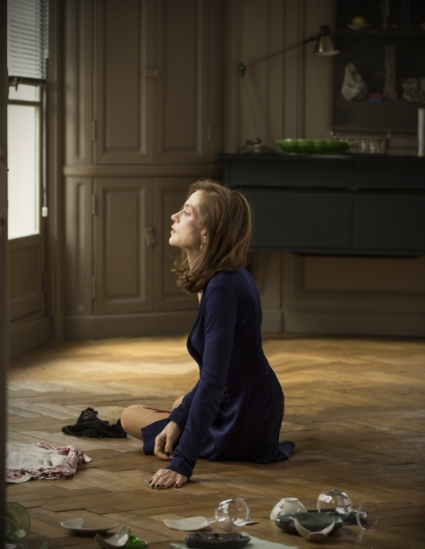

Interview PAUL VERHOEVEN

Where did you get the idea to adapt Philippe Djian’s novel “Oh…” ?
The idea wasn’t mine; it came from the producer, Saïd Ben Saïd. He contacted me in the US, sent me Philippe Djian’s novel, which I read and found very interesting. I knew we had the material for a movie, but I had to think it through and find my way of appropriating a story I would never have come up with myself.

How did the adaptation process go?
It was very important for me to reappropriate the story. A lot of things were thrashed out in conversations with David Birke, who wrote the American screenplay. I never write the first draft of a script, I always leave that to a real screenwriter. At that stage, everything was still open: things gradually took shape, like a sculpture. My personality as director gradually insinuated itself into the story. The storyboard stage was also crucial to making the novel mine by providing a visual translation of the action.

At one stage, then, the plan was to shoot Elle in the US?
Yes, which explains picking out an American writer, with a view to shifting the action from Paris to Boston or Chicago, with a wholly American cast. But it was tricky, artistically as well as financially. We realized that no American actress would ever take on such an amoral movie. Even for actresses I know really well, it was impossible to say yes to this part, whereas Isabelle Huppert, whom I had met at the outset, was very keen to do the movie. Around six months in, Saïd said to me, “Why are we fighting to make the movie in the US? It’s a French novel, Isabelle Huppert is keen to do it—we’re stupid!” And he was right. I realize now that I could never have made this movie in the US, with this level of authenticity.

Like most of your heroines, Michèle is a strong woman, but she reacts in a disturbing way to this rape.
It’s a story, not real life, nor a philosophical vision of women! This particular woman acts that way, which doesn’t mean that all women will or should act that way. But Michèle does! And my job consisted above all in directing this story in the most real, interesting and credible way possible. Thanks especially to Isabelle Huppert, whose incredible performance makes her character’s behavior completely convincing.

Thanks also to your direction, which never seeks to explain.
Of course, there is nothing to explain. Explaining is what the audience has to do for itself using the elements they’ve been given, without one of them justifying everything on its own. For example, I didn’t want anyone to be able to say that Michèle was so traumatized as a child by her father’s acts that it’s normal for her to react to the rape that way. I wanted to escape that constrained vision of the character and her behavior. It’s a possibility but no more than that. The explanation is, simply, Michèle, in every aspect of her personality. As for working out if she was always like that or became that way because... We just don’t know.

You are a master of the art of ambiguity.
When Isabelle Huppert saw the movie, that was one of the things she said to me: “The most interesting aspect is the perpetual ambiguity”. She’s right, it’s always ambiguous. It’s hard to completely grasp this woman. Everything is fluctuating, strands intertwine... I had already done that in other movies, particularly TOTAL RECALL—in a totally different genre—by combining dream and reality. At the end, you’re not sure what to think. It’s unclear. I like keeping options open. Just like in life, you never know what’s hiding behind a smile. Or not.

Very early on, Michèle pictures a scene of her killing her attacker. This fantasy scene contributes to the atmosphere of blurred lines and to the expression of this woman’s complex personality.
Yes, Michèle has no problem imagining her rapist’s death. And at the end of the movie, when it actually occurs and her rapist removes his mask before dying, a smile flickers across her face. It’s a very important moment that we discussed at length with Isabelle. What she does is minimal—she doesn’t act, she doesn’t intervene, she just thinks and we see her thinking, “It’s all you deserve. You’re paying for what you did at the start”. There’s a hint of divine retribution in her eyes. And irony: “You should have seen it coming. Now, it’s too late!”.

The rape scenes are like black holes in a tale of daily life that starts back up again for Michèle, as if nothing had happened.
I like doing that a lot. In ROBOCOP, for example, I interspersed the storytelling with news footage and fake commercials. I think it comes from my interest in painting, in Mondrian, with the juxtaposition of blue and red squares interrupted by black lines. The rape scenes had to be disturbing. If I shot them like the rest of the story, it would have been nonsensical and dishonest. We had to be confronted with the violence of those scenes.

Despite the violence of the attacks, we never see Michèle downcast or “damaged”.
No, that would be too conventional. We’d be slipping into melodrama and boredom. It’s more interesting and amusing to surprise the audience, rather than happily regurgitate what has already been done by other directors and writers. I’m a great admirer of Stravinsky and his unusual way of composing his symphonies, of subverting the norm. Also, that artistic decision keys into the character of Michèle and her attitude to events: I was raped but I’m here now and it doesn’t matter. Let’s order a drink and some dinner!

Your choice also has moral implications: you don’t lock Michèle into a status as victim. She deploys irony with astonishing vivacity.
Just like the plot, morality is open to manipulation in this movie. As soon as we can, we have to try to veer off the beaten path. Djian doesn’t make Michèle a victim either. Taking the opposite course would have been unfaithful with regard to the book.

The violence endured by Michèle is also a means of selfknowledge, of owning your own violent inclinations...
She’s already made a good job of owning them! Michèle is a very aggressive woman. Her mother criticizes her for wanting everything to be healthy and sanitized, but I confess I never understood that line, which came from the book! Her attitude toward her mother, her son and his girlfriend is very harsh. She expresses great animosity toward them, and toward her friends and acquaintances generally. There is violence in all my movies, but it seems normal to me—it’s simply the violence in the world that makes headlines in the press, on every page, not just the front page. The media is full of bad news: we’re addicted to disasters because disasters are fascinating and can be beautiful as well. Seen from a particular distance, like Turner paintings, destruction can be sublime. Close up, of course, it’s horrible.

One scene captures the contradictory emotions we feel while watching: Michèle’s confession of her father’s murders to Patrick. We are in turn horrified, amused, skeptical, touched...
Yes, the way she tells the whole gruesome story with a smile... That scene wasn’t in the novel. David Birke wrote it and Isabelle immediately understood that it needed to be played lightly to string us along. You can’t work out is she’s emotional or fooling with Patrick. Very few actresses could do what she does. And in the background, there’s the music of the mass. Finally, in similar tones, the film’s score takes over almost up to Michèle’s “Not bad, huh?” Then we go back to the music from the mass, whose gravity and solemnity give the scene an emotional dimension that contrasts with Isabelle’s lighthearted tone.

This is the first film you’ve shot in France.
And it was hugely enjoyable because there is a lot of respect in France for film and directors. More than in Holland or the USA. So there was no problem, except with my brain! Before I came here to make the movie, I had terrible headaches that my doctor couldn’t explain. The moment I moved to Paris and started work on the movie, they went away for good. In fact, the headaches came from fear—fear of the unknown, fear of diving into a different culture and different language. After a few weeks in Paris, my brain realized I had enough hold over the film, and came to terms with the whole extraordinary adventure. Having made movies in Holland for twenty-five years, then for another fifteen in the United States, it really was a step into the unknown, from a quasiexistential point of view. Everything was new to me—actors, crews, locations... And that was great because when you launch yourself into the unknown, you become extremely creative and inspired. I felt the same when I left Holland to make ROBOCOP in the States.

The novel’s French mindset is shaken up by your direction. Even the dinner scenes are pure action!
The film focuses on the social interactions of all these characters more than the actual crime story. I prepped for it by watching French films, but I really wanted to make something different with constant tension. That’s the only way I know how to work, by repeatedly breaking up the linearity of the story, which explains, for example, the scene in the car between Patrick and Michèle after the party. It wasn’t in the novel—David wrote it to reinject some narrative tension. Michèle has just admitted to Anna that she was having an affair with Anna’s husband and now she threatens Patrick, saying she’ll tell everything to the police. When she gets out of the car, will he try to kill her? She seems to half-expect it and a very scary game plays out between them.

And working with French actors?
Fabulous. And not very different from working with other actors. In most cases, I wasn’t familiar with their previous work. I picked them mostly on instinct. I wanted them to be beautiful, alluring, and not too French-looking! I think I filmed them through an American filter almost. We had a few conversations and my directions were fairly basic—less movement, pare it down. It was fascinating, for example, to see an excellent actor, such as Charles Berling, change his style of performance from one minute to the next.

Was Isabelle Huppert familiar with your work?
Six or seven years ago, TURKISH DELIGHT was screening at La Cinémathèque Française and Isabelle was there to present the movie. She said that she first saw it when she was very young and that it was one of the reasons why she became an actress. Isabelle is fearless. Nothing is a problem for her. She will try anything, she is phenomenally bold.

And Laurent Lafitte?
When we met, I asked Laurent to do the scene where he offers to show Michèle the boiler in his basement, with a dangerous, almost demonic twinkle in his eyes, whereas he is so upbeat and smiling the rest of the time. And he was able to do it. And he’s so handsome! Then we chose Virginie Efira. We’d written his wife as a withdrawn, not very happy woman, but that made Patrick’s urge for an affair with Michèle far too comprehensible. It was better for her to be beautiful and adult. Virginie is pitch perfect, even though her sex appeal is exploited here less than in other films. As soon as I met her, it was obvious she was right for the part. As for Anne Consigny, Judith Magre, Vimala Pons and Alice Isaaz, they all have a lot of character!

And your choice of Stéphane Fontaine as DP?
I wanted a kind of looser feel, not over-framed. I studied the work of several French DPs, and there was some of that in A PROPHET AND RUST AND BONE, the two Audiard pictures that Stéphane Fontaine lit. I suggested we shoot with two cameras—a method I had just used in Holland on Tricked, a TV movie written by online contributors. Every set-up was planned for two cameras, often placed very close to each other to facilitate continuity, so the cuts in editing weren’t as obvious. I did more long takes than usual, with hand-held cameras. I wanted a kind of casual aspect, like somebody watching. The camera moves slightly, in almost voyeuristic observation.

During the first two attacks, the soundtrack is scaled down. We have to wait for the scene in the basement for you to break out the symphonic music.
That basement scene starts with electronic music, like the two earlier rape scenes, but orchestral music then fades in. We had long talks with Anne Dudley, our English composer, about what we wanted to express. It’s absolutely clear, at that moment, that Michèle is consenting, that she has responded positively to his invitation in what is almost a scene of seduction. She has taken the decision to play this masochistic game on her own terms.

You might think this powerful woman perhaps agrees to play out a game of domination to reenact the murders perpetrated by her father, while controlling the exact sequence of events this time.
Sure, even if I don’t say so explicitly. It’s up to audiences to draw their own conclusions. He’s just had his orgasm and he gets up. Only then does she climax too. Something rises in her that, I think, has to do with everything that happened so many years before. Just then, thanks to this masochistic game perhaps, she releases all the accumulated misery. At least, that’s how I described it to Anne Dudley, so that her score would aim for a tragic, romantic feel.

In the novel, Michèle isn’t present at the time of her father’s tragic actions. In your movie, not only is she there, there is also the picture of her staring into space on the TV news. It’s an image that brings to mind a fantasy or horror movie.
True, it wasn’t in the novel. Once again, it was David Birke’s idea, but he was undoubtedly inspired by the Michèle character that Djian had created. That’s all part of the process of turning a novel’s words into moving pictures.

And the reconstitution of the primetime crime investigation documentary?
I watched a lot of tapes of similar shows to absorb their esthetic approach and copy the way they frame and edit shots. While the rest of the film tends toward elegance, I asked Stéphane Fontaine to film these scenes in a jerkier style, and I accentuated it in editing. Then we worked on the footage to give it a grainier, older feel. The whole point was to make audiences feel they are watching genuine archive footage of real-life events. That was also the case in Djian’s novel. He came up with the whole story by drawing his inspiration from Norwegian mass murderer Anders Behring Breivik.

Who conceptualized the video game produced by Michèle and Anna’s company?
Creating a video game from scratch would have been too expensive. We didn’t have time to do it, either, so we based it on an existing French video game that we tweaked to fit the story. The video game heightens the atmosphere of violence, especially with the porn video that is posted to the whole staff’s computers. In the novel, Michèle and Anna work in the screenwriting business, but it seemed a boring job to film, not at all visual! I was in L.A. with my family, wondering what I could do with that, and my daughter, who is a painter, said, “How about they work in video games?”.

The character of Patrick’s wife, Rebecca, is more prominent then in the novel and has one of the last lines in the movie, and not the least important one!
I’m no Christian, and I’ve never been in a church, except Notre Dame to admire the architecture, but I have some interest in religion. I studied the life of Jesus for a book and I’d like to make it into a movie. Just like sex and violence, religion is very important. Twenty years ago, everybody thought religion’s influence severely diminished, but it is all over our societies again now, and not in a positive way. So I thought it would be interesting to show a character truly driven by her faith. Rebecca is slightly naïve and very devout. She goes on a pilgrimage de Santiago de Compostela. Whenever I could, I enjoyed cranking up the religious dimension, especially at the dinner when she asks to bless the meal, and then to watch midnight mass. And at the end, she informs Michèle that she was aware of her husband’s actions. Like the Catholic church, which knew for years what some priests were doing to little boys.

And the film’s title?
“Oh…” brought to mind The Story of O, a book that the French producer Pierre Braunberger asked me to adapt right after TURKISH DELIGHT. ELLE was my producer’s idea and I find that it captures what lies at the heart of a movie focused on this singular woman.

At the end, when Michèle and Anna walk away together,we’re not sure just how far they’ll go.
When we shot that scene, they ended up kissing, but it was too much and not at all in the style of the movie, which never says things explicitly. Same goes for when they’re in bed together. I had shot what happened next, the two of them making love, but there were already enough clues, so I preferred to cut to next morning and leave everything to audiences’ imaginations, if they cared to imagine it. When you deploy irony, you have to play on nuances and doubt, and never throw an interpretation into audiences’ faces.

Interview by Claire Vassé

Filmografie PAUL VERHOEVEN

• ELLE
• TRICKED
• BLACKBOOK
Young Cinema Award – Best International Film (Venice)
Best Director and Best Actress (Netherlands Film Festival)
Best Dutch Film and Best Dutch Actress (Rembrandt Award)
• HOLLOW MAN
Leopard of Honor and Audience Award (Locarno)
• STARSHIP TROOPERS
• SHOWGIRLS
• BASIC INSTINCT
• TOTAL RECALL
Academy Award for Best Visual Effects
Academy Award Nomination for Best Sound and Best Sound Effects Editing
• ROBOCOP
Best Science Fiction Film, Best Director, Best Make-up, Best Writing,
Best Special Effects (Saturn Awards)
• FLESH + BLOOD
Best Film and Best Director (Netherlands Film Festival)
• THE 4TH MAN
International Critics’ Award (TIFF)
• SPETTERS
• VOORBIJ, VOORBIJ (TV MOVIE)
• SOLDAAT VAN ORANJE / LE CHOIX DU DESTIN
Golden Globe Nomination for Best Foreign Language Film
• KEETJE TIPPEL
• TURKISH DÉLICES
Best Dutch Film of the Century (Netherlands Film Festival)
Academy Award Nomination for Best Foreign Language Film
• BUSINESS IS BUSINESS
• DE WORSTELAAR
• FLORIS (12 EPISODES – TV SERIE)
• PORTRET VAN ANTON ADRIAAN MUSSERT
(TV DOCUMENTARY)
• HET KORPS MARINIERS (SHORT – DOCUMENTARY)
Silver Medal (International Military Film Festival, Versailles)
• FEEST ! (SHORT)
• DE LIFTERS (SHORT)
• NIETS BIJZONDERS (SHORT)
• EEN HAGEDIS TEVEEL (SHORT)
Best Film (Cinestud International Student Film Festival Amsterdam)

Interview ISABELLE HUPPERT

You joined the ELLE project at a very early stage.
Yes, I read “Oh…” and met with Philippe Djian, who told me that he hadn’t written it for me, but that he had me in mind at various moments during the writing of the novel. The book, as a lot of people said when it came out, reads like a screenplay. You can’t help thinking it could become a movie. Then Saïd Ben Saïd made his entrance: he bought up the rights and we started to think about a director. It was Saïd who thought of Paul Verhoeven.

What did you like about the novel and this female character?
Michèle is a woman who doesn’t fall. Never. She is many and varied: cynical, generous, endearing, cold, commendable, independent, dependent, perspicacious. She is anything but sentimental; she is pummeled by events, but she doesn’t crack. Verhoeven held firm on that, without trying to whittle away at our fundamental position. You could rely on him for that. That’s the point of the character—her strength, originality and modernity. She never behaves like a victim, even when she has every reason to do so: victim first of her mass murderer father and then of her rapist. Guilt, submitting to events—so many notions that it is hard to rid from female characters. Even if they are strong women, they always have that hanging over them in the movies: the temptation to veer toward emotion, which turns out to be phony—a slightly gooey sentimentalism.

Thanks to your performance—always slightly removed and playful—you dodge that slippery slope.
Yes, I resisted. Making her mellower would have been a serious mistake. But once again with Verhoeven, there was no chance of that! The only time I allowed myself to hint at emotion is at the hospital when her mother is sick and we realize that she is dying. Suddenly, Michèle kind of softens. Not when she’s a mother, lover or her father’s daughter, but when she’s her mother’s daughter. For a woman, is one’s mother’s death the moment you irrevocably become an adult? I’m extrapolating slightly, but I mean to say that, at that particular moment, I may not have been displeased for the camera to capture that—a touch more emotion, tears welling up, a frantic flicker of the eyes. But the cinema has an unconscious, too! Whatever it refuses, it refuses to see.

Were you familiar with Verhoeven’s work?
Yes, of course. The first of his movies that I saw was TURKISH DELIGHT. Its heroine is practically the opposite of Michèle, a modern-day Lady of the Camellias, finally succumbing to illness. It was a kind of poignant, tragic fairy tale. The last thing you’d expect from Verhoeven. Elle is also a kind of fairy tale. From that point of view, Verhoeven and Djian were a perfect fit. While speaking to the period, by some sort of sleight of hand they make us take things at face value, without trying to reposition them in a psychological or overly emotive context. The fairy tale allows for a kind of abruptness—there’s no need to explain or justify things—down to the geography of the movie that contrasts city and suburbs, which are depicted with a hint of poetry, radiating a sense of nature and solitude.

The film gives us clues to your character but none, not even the father’s murders, completely explains her.
Yes, the film moves too fast for that. Trying to explain the characters might tend to shatter the balance that is the story’s strength by dragging it into the drudgery of attempted explanations. Michèle is totally in the scene at the moment it occurs. What matters is how she moves forward, not backward.

Michèle’s confession of her father’s murders to Patrick captures this refusal to congeal your character in explanations. You swing us through horror, humor, doubt, emotion...
Once more, the plan wasn’t to tell a tale of pain. Michèle has taken a step back—it was the only way for her to survive her past. She serves all that up with devastating humor, as if she were holding out a plate of poison and saying, «A second helping, surely?» Djian doesn’t believe in half-measures. Her father killed seventy young children and she has to live with that ignominy, that catastrophe.

One might think that during the attack in the cellar, she reruns the trauma she experienced with her father and then with her rapist first time around, but this time with a measure of control over events and over the violence.
Yes. Let’s say that the rape unleashes a desire for violence in her, which may have been dormant since she was a young child. As a master manipulator, she knows how to orchestrate all that, even though she is aware that everything within her has been turned on its head by this rape. She doesn’t come out of it unscathed.

Was it a problem for you to play the part of a woman who enjoys intimacy with her rapist?
Once again, the film is a fairy tale. And the fairy tale leads to fantasy. The effect of reality is modified, altered. In a fairy tale, everything is exaggerated, so anything is possible. Morality is kindly requested to step off. A game is played out between Michèle and her rapist, and it’s her choice.

What was it like on set with Paul Verhoeven? How does he work with his actors?
He has the formidable precision of an entomologist. His attention to the tiniest detail is almost mind-blowing. You feel very free around him, you can come up with thousands of ideas. The shoot was like doing 300 mph down the freeway. I was in almost every shot for the twelve weeks of shooting. At no point was there a let-up in the pressure and tension. I reveled in the infernal rhythm of one shot after another. It was never-ending, and this almost hallucinatory precision kept you constantly on your toes. It’s like an intoxicating liquor. Paul swept the whole crew along behind him. They would have done anything for him. Paul is never tired; nothing ever stops him. He could leave us absolutely drained at the end of the day, while he kept working for five more hours.

How does Verhoeven, the Dutch director who has made movies in Hollywood, work differently from a French director?
He possesses a sense of rhythm and movement, and he doesn’t hesitate to blur the line without wondering whether he’s making a portrait of a woman, a snapshot of society, or a genre movie or thriller. I’m not saying that a French filmmaker wouldn’t do that, but let’s just say that it would be more of a surprise.

The film sometimes dares to verge on romanticism, particularly in the scene where Patrick helps Michèle to close the shutters.
In all his movies, he constantly plays with codes, subverts them, uses them when he needs them, then abandons them. He never falls into the trap of his film veering off in one direction and not coming back.

Even the meal scenes are suffused in action and the sheer pleasure of making movies.
That pleasure, I felt it every moment of every day. The blocking and direction of actors are nothing less than the art of movement: how the camera embraces the actors, how it espouses both their inner rhythm and their relationship with the outside world. The actor is like a sponge, unconsciously reactive to the precision of that movement and the distance with regard to the camera. The direction of a given scene really does resolve all the issues that you might ask yourself when you act.

Whereas in Djian’s novel she works in movies, in the film Michèle is in the video games business.
Verhoeven uses the phantasmagoria of video games as a contemporary extension of the fairy tale dimension. A blend of sex and violence, like an allegorical echo of the movie’s whole story.

The men don’t necessarily come out of this well, especially Robert, Michèle’s lover, to whom she says, «Your stupidity was what first attracted me».
Yes, the men constantly get knocked down to size. The son, the husband, the lover, and even the rapist! But for all their weakness—spinelessness, in some cases—these men are neither despised, nor despicable. Their flailing vulnerability is endearing. But it is a fact: Michèle is a strong woman, a woman of her times, who has taken power. Economic, social and sexual power—a minor revolution revealing men’s weakness.

At the end of the movie, Michèle and Anna walk away together. How far will they go?
Sure, they walk away, but through a graveyard not a field of roses. How far? I don’t know. Together, at least.

Interview by Claire Vassé
Filmografie ISABELLE HUPPERT

• THINGS TO COME - Mia HANSEN-LØVE
• RIGHT HERE RIGHT NOW - Pascal BONITZER
• ELLE - Paul VERHOEVEN
• LOUDER THAN BOMBS - Joachim TRIER
• VALLEY OF LOVE - Guillaume NICLOUX
• ABUSE OF WEAKNESS - Catherine BREILLAT
• TIP TOP - Serge BOZON
• DORMANT BEAUTY - Marco BELLOCCHIO
• AMOUR - Michael HANEKE
Palme d’Or – Cannes Film Festival
• IN ANOTHER COUNTRY - HONG Sang-Soo
• CAPTIVE - Brillante MENDOZA
• COPACABANA - Marc FITOUSSI
• VILLA AMALIA - Benoît JACQUOT
• THE SEA WALL - Rithy PANH
• HOME - Ursula MEIER
• WHITE MATERIAL - Claire DENIS
• PRIVATE PROPERTY - Joachim LAFOSSE
• GABRIELLE - Patrice CHÉREAU
Special Golden Lion for GABRIELLE and her overall career
Venice Film Festival
• I HEART HUCKABEES - David O’RUSSELL
• GHOST RIVER - Olivier DAHAN
• 8 WOMEN - François OZON
Collective Silver Bear for the 8 actresses – Berlin International Film Festival
Collective European Film Award for the 8 actresses
• THE PIANO TEACHER - Michael HANEKE
European Film Award for Best Actress
Best Actress Award – Cannes Film Festival
• COMEDY OF INNOCENCE - Raoul RUIZ
• MERCI POUR LE CHOCOLAT - Claude CHABROL
• SENTIMENTAL DESTINIES - Olivier ASSAYAS
• THE KING’S DAUGHTERS - Patricia MAZUY
• MODERN LIFE - Laurence FERREIRA BARBOSA
• THE SWINDLE - Claude CHABROL
• ELECTIVE AFFINITIES - Paolo et Vittorio TAVIANI
• LA CÉRÉMONIE - Claude CHABROL
César Award for Best Actress
Volpi Cup for Best Actress – Venice Film Festival
• LA SÉPARATION - Christian VINCENT
• AMATEUR - Hal HARTLEY
• THE FLOOD - Igor MINAEV
• LOVE AFTER LOVE - Diane KURYS
• MADAME BOVARY - Claude CHABROL
Silver George for Best Actress – Moscow International Film Festival
• MALINA - Werner SHROETER
Bundes Film Preis
• A WOMAN’S REVENGE - Jacques DOILLON
• MIGRATIONS - Alexandar PETROVIC
• STORY OF WOMEN - Claude CHABROL
Volpi Cup for Best Actress – Venice Film Festival
• THE POSSESSED - Andrzej WAJDA
• THE BEDROOM WINDOW - Curtis HANSON
• CACTUS - Paul COX
• ALL MIXED UP - Josiane BALASKO
• MY BEST FRIEND’S GIRL - Bertrand BLIER
• THE STORY OF PIERA - Marco FERRERI
• ENTRE NOUS - Diane KURYS
• THE TROUT - Joseph LOSEY
• PASSION - Jean-Luc GODARD
• EAUX PROFONDES - Michel DEVILLE
• COUP DE TORCHON - Bertrand TAVERNIER
• THE LADY OF THE CAMELIAS - Mauro BOLOGNINI
• HEAVEN’S GATE - Michael CIMINO
• EVERY MAN FOR HIMSELF - Jean-Luc GODARD
• LOULOU - Maurice PIALAT
• VIOLETTE NOZIÈRE - Claude CHABROL
Best Actress Award – Cannes Film Festival
• THE LACEMAKER - Claude GORETTA
BAFTA Award for Best Actress

In Front of the Camera

LAURENT LAFITTE der Comédie-Française
2017 • AU REVOIR LÀ-HAUT - Albert DUPONTEL
2016 • ELLE - Paul VERHOEVEN
2015 • DADDY OR MOMMY - Martin BOURBOULON
• BOOMERANG - François FAVRAT
• THE EASY WAY OUT - Brice CAUVIN
2014 • ELLE L’ADORE - Jeanne HERRY
• FOOL CIRCLE - Vincent MARIETTE
• THE LOVE PUNCH - Joël HOPKINS
2013 • 16 ANS OU PRESQUE - Tristan SÉGUÉLA
• MOOD INDIGO - Michel GONDRY
2012 • ON THE OTHER SIDE OF THE TRACKS - David CHARHON
2011 • BORDERLINE - Alexandre COFFRE
2010 • LITTLE WHITE LIES - Guillaume CANET
• THE PERFECT DATE - Dominique FARRUGIA & Arnaud LEMORT
2007 • A SECRET - Claude MILLER
2006 • TELL NO ONE - Guillaume CANET
2004 • NARCO - Gilles LELLOUCHE & Tristan AUROUET
• THE ROLE OF HER LIFE - François FAVRAT
2003 • MAIS QUI A TUÉ PAMELA ROSE ? - Éric LARTIGAU
2002 • WHATEVER YOU SAY - Guillaume CANET
2000 • THE CRIMSON RIVERS - Mathieu KASSOVITZ

ANNE CONSIGNY
2016 • ELLE - Paul VERHOEVEN
2015 • 7 MINUTI - Michele PLACIDO
• HISTORY’S FUTURE - Fiona TAN
2014 • 96 HOURS - Frédéric SCHOENDOERFFER
• SWIM LITTLE FISH SWIM - Ruben AMAR, Lola BESSIS
2013 • 60 GOING ON 12 - Frédéric PROUST
• THE SIESTA UNDER THE FIG TREE - Anne-Marie ETIENNE
2012 • YOU AIN’T SEEN NOTHIN’ YET ! - Alain RESNAIS
2009 • RAPT - Lucas BELVAUX
• BAMBOU - Didier BOURDON
• WILD GRASS - Alain RESNAIS
• JOHN RABE - Florian GALLENBERGER
• MEET THE ELISABETHZ - Lucien JEAN-BAPTISTE
2008 • A CHRISTMAS TALE - Arnaud DESPLECHIN
• THE GREAT ALIBI - Pascal BONITZER
• GUILTY - Laetitia MASSON
2007 • THE DIVING BELL AND THE BUTTERFLY - Julian SCHNABEL
2005 • NOT HERE TO BE LOVED - Stéphane BRIZÉ
2003 • THE LIGHT - Philippe LIORET
1984 • THE SATIN SLIPPER - Manoel DE OLIVEIRA

CHARLES BERLING
2016 • ELLE - Paul VERHOEVEN
• LE COEUR EN BRAILLE - Michel BOUJENAH
2015 • WE WANTED TO BREAK EVERYTHING - Philippe GUILLARD
• THE CLEARSTREAM AFFAIR - Vincent GARENQ
2011 • FORBIDDEN HOUSE - Hélène ANGEL
2008 • SUMMER HOURS - Olivier ASSAYAS
2006 • MADE IN PARIS - Pascal BONITZER
• THE MAN OF MY LIFE - Zabou BREITMAN
2005 • GRABUGE - Jean-Pierre MOCKY
2003 • PÈRE ET FILS - Michel BOUJENAH
2001 • COMEDY OF INNOCENCE - Raoul RUIZ
2000 • SENTIMENTAL DESTINIES - Olivier ASSAYAS
César Award Nomination for Best Actor
1998 • THOSE WHO LOVE ME CAN TAKE THE TRAIN - Patrice CHÉREAU
• L’ENNUI - Cédric KAHN
César Award Nomination for Best Actor
1997 • LES PALMES DE MONSIEUR SCHULTZ - Claude PINOTEAU
• DRY CLEANING - Anne FONTAINE
César Award Nomination for Best Actor
1996 • RIDICULE - Patrice LECONTE
César Award Nomination for Best Actor
1995 • L’ÂGE DES POSSIBLES - Pascale FERRAN
• NELLY AND MR ARNAUD - Claude SAUTET
1994 • COMING TO TERMS WITH THE DEAD - Pascale FERRAN
César Award Nomination for Best Promising Actor
1981 • HOME MURDERS - Marc LOBET

VIRGINIE EFIRA
2016 • ELLE - Paul VERHOEVEN
• VICTORIA - Justine TRIET
• PRIS DE COURT - Emmanuelle CUAU
• UP FOR LOVE - Laurent TIRARD
• ET TA SOEUR - Marion VERNOUX
2015 • FAMILY FOR RENT - Jean-Pierre AMÉRIS
• THE SENSE OF WONDER - Éric BESNARD
• CAPRICE - Emmanuel MOURET
• HÔTEL TRANSYLVANIA 2 - Genndy TARTAKOVSKY
2013 • LES INVINCIBLES - Frédéric BERTHE
• TURNING TIDE - Christophe OFFENSTEIN
• IT BOY - David MOREAU
• DEAD MAN TALKING - Patrick RIDREMONT
2011 • MY WORST NIGHTMARE - Anne FONTAINE
• SECOND CHANCE - Nicolas CUCHE
2010 • THE PERFECT DATE - Dominique FARRUGIA & Arnaud LEMORT
• THE WHISTLER - Philippe LEFEBVRE

Behind the Camera

DAVID BIRKE – Drehbuch
Feature films
2017 • DEADWORLD - Gregor JORDAN
2016 • ELLE - Paul VERHOEVEN
2014 • 13 SINS - Daniel STAMM
2010 • FREEWAY KILLER - John MURLOWSKI
2002 • DAHMER - David JACOBSON (ohne Credit)
1990 • HORSEPLAYER - Kurt VOSS
TV Movies
1996 • A KIDNAPPING IN THE FAMILY - Colin BUCKSEY
• FOR BETTER OR WORSE - Andy WOLK
1992 • THE FEAR INSIDE - Leon ICHASOFEAR I

PHILIPPE DJIAN – Autor der Romanvorlage
Films adapted from his novel
2016 • ELLE - Paul VERHOEVEN
2014 • LOVE IS THE PERFECT TIME - Jean-Marie LARRIEU, Arnaud LARRIEU
2011 • UNFORGIVABLE - André TÉCHINÉ
1986 • BETTY BLUE - Jean-Jacques BEINEIX
• BLUE HELL - Yves BOISSET
Script and dialogue written by Philippe Djian
2004 • NE FAIS PAS ÇA ! - Luc BONDY
NSIDE - Leon ICHASO

